**Implement Web Drivers on various Browsers:**

**CODE inside jhoncena.java:**

|  |
| --- |
| package demowork;  import org.openqa.selenium.WebDriver;  import org.openqa.selenium.chrome.ChromeDriver;  import org.openqa.selenium.edge.EdgeDriver;  import org.openqa.selenium.firefox.FirefoxDriver;  import java.util.Scanner;  public class jhoncena {      public static void main(String[] args) {          // TODO Auto-generated method stub          //System.setProperty("webdriver.chrome.driver", "")            WebDriver driver = null;          Scanner scanner = new Scanner(System.in);            System.out.println("Pick your browser (chrome, edge, firefox):");          String browser = scanner.nextLine();            System.out.println("Enter the URL: ");          String url = scanner.nextLine();            switch (browser.toLowerCase()) {              case "chrome":                  driver = new ChromeDriver();                  break;              case "firefox":                  driver = new FirefoxDriver();                  break;              case "edge":                  driver = new EdgeDriver();                  break;              default:                  System.out.println("Invalid browser choice");                  System.exit(0);          }            driver.get(url);          driver.manage().window().maximize();            String name = driver.getTitle();          System.out.println("Page title is: " + name);            // Close the scanner          scanner.close();            // Close the browser          //driver.quit();      }  } |

**OUTPUT:**

**With chrome:**

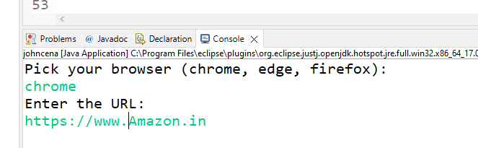

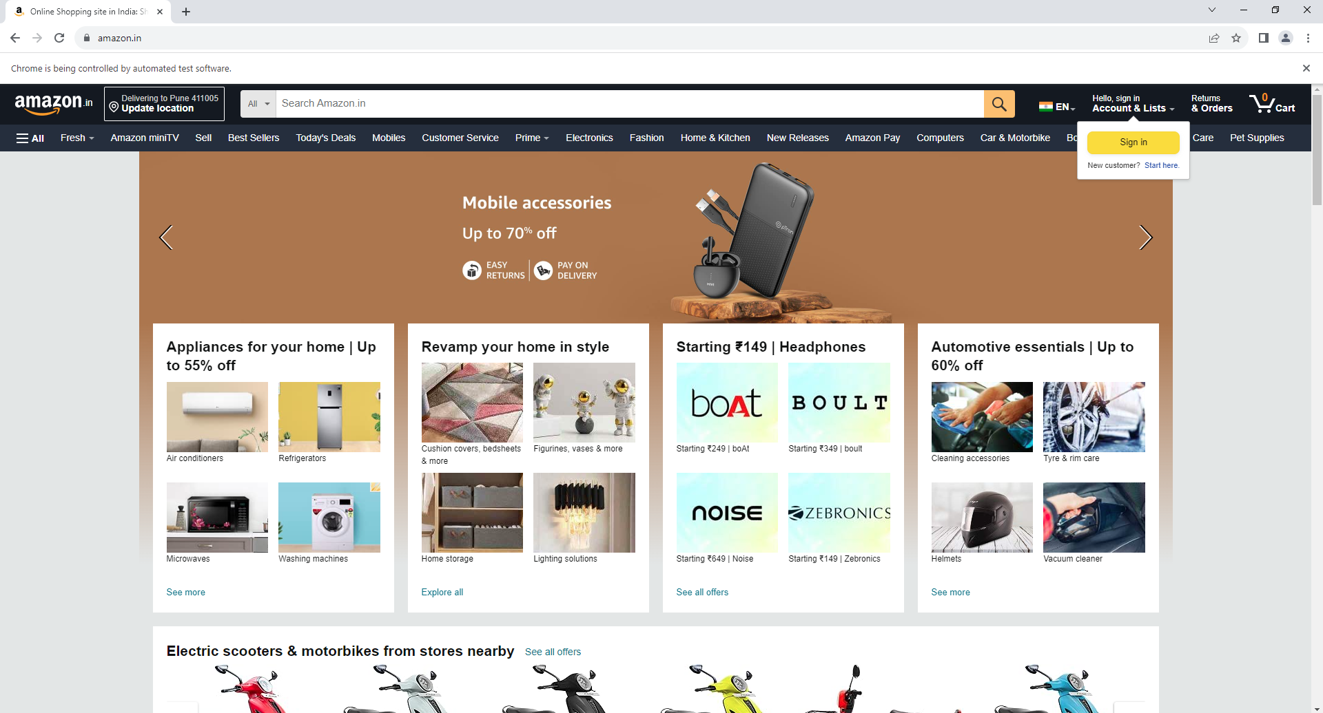

**With Firefox:**

